How A 121-Storey Building Uses A Giant Magnet To Prevent Swaying
Chris Mills
3/20/15 1:00am
When you're building a skyscraper with triple-digit numbers of storeys, there are some rather unusual building challenges to face — like the fact that the entire building can sway with the wind, fast enough to make people sick. The Shanghai Tower solves that problem in a scientifically awesome way: using magnets.
The problem of winds and tall skyscrapers isn't a new one. The issue isn't so much the pure force of the wind — skyscrapers aren't usually in danger of being blown over — but rather, the oscillations that come with the gusts. They can be big enough to send the top of the tower meters in either direction, giving occupants a bad stomach (and probably a terrifying case of vertigo).
More problematically, frequent motion can cause structural fatigue, which aren't two words you want to hear when your office is half a mile off the ground.
The traditional solution has been a pendulum. Hang a big weight close to the top of a tower, and the inertia of that mass will damp, if not completely reduce, any swaying motion. But the traditional solution doesn't work so well at scale — the swinging mass of the pendulum itself becomes a problem.
This is where the 'tuned mass' damper system of the 2,073-foot Shanghai Tower comes into play. The physics of the damper work exactly as normal — a 1,000 ton weight hangs from steel cables. But two systems prevent the weight from moving too far or two fast: hydraulic rams, and a 'tunable', self-generated magnetic field.
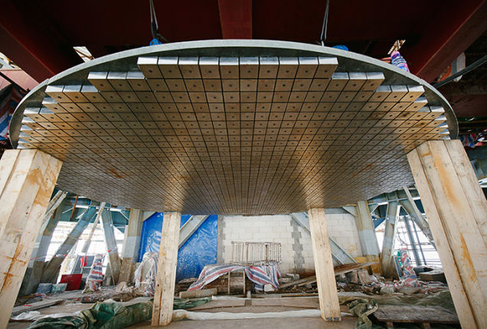
Eddy Damper Current plate. Image: Noah Sheldon/Gensler
The iron weight hangs above 10m x 10m copper plate, which is studded with 125 powerful magnets. As the iron swings over the magnets, it induces an electrical current in the copper plate, which in turn is enough to limit the motion of the mass. The beauty is in the simplicity: there's no outside power source, and it's a completely self-regulating system. The faster the weight moves, the stronger the magnetic field containing it. [Popular Mechanics/Gensler]
Image credit: AP Photo/Eugene Hoshiko

